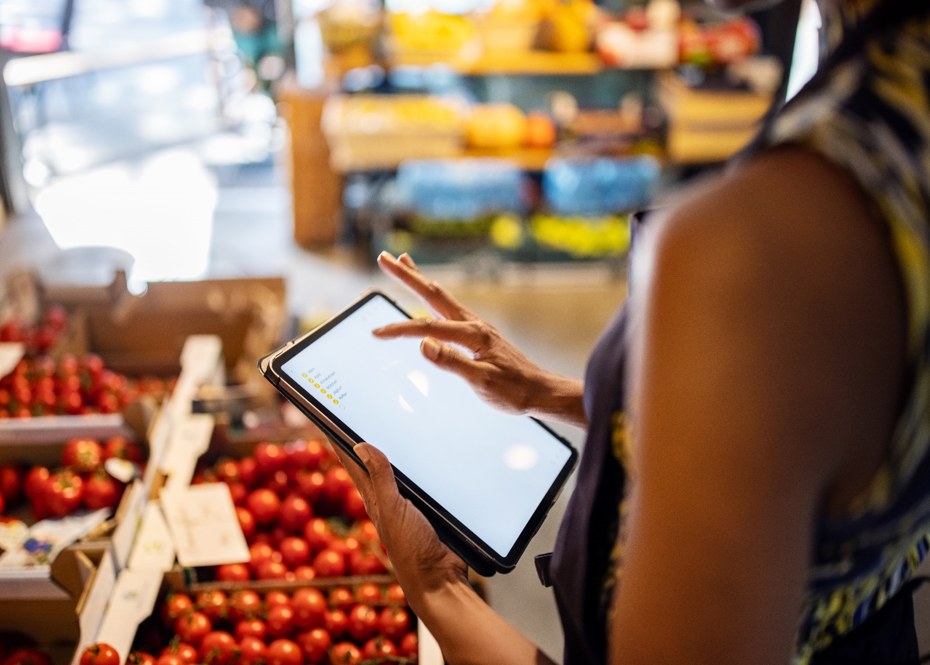

Omphile Disemelo

4358375@myuwc.ac.za

Specific Requirements Specification

Inspired by Checkers Sixty60

Fresh Finders

Grocery Shopping System

Fresh Finders is a Grocery Shopping System and is a Java-based application that aims to help customers with their Groceries. This grocery system enables you to do your shopping in the comfort of your own home.

**Stakeholders**

The customer wants an On-Web Shopping System that will enable them to select the groceries they want from the Fresh Finders Shopping platform. The Groceries Shopping System must be able to calculate the amount the user need to pay when they get to the store. The helpers at the Fresh Finders Store will then pick out the groceries from the isle, put them in plastics and then the user will get them at the counter and then pay for them.

**Scrum Team Roles**

The product owner represents the stake holders and will tell the Scrum team if the features of the grocery online store meet their requirements.

The Scrum master will ensure that the team works at a pace that is more efficient towards meeting the deadline.

The Developers are in charge of the Java development, wherein the user’s details are going to be store. The user can select their groceries. At the end of their selection, the system is able to calculate the amount due for the groceries.

**Product Backlog**

Product Features

The online grocery system will enable the user to select their groceries from the website and calculate the total they need to pay when they go pick up their groceries at the Fresh Finders Store.

Limitations

The groceries will not be delivered to the users’ homes. When the user is done selecting their groceries they need to pick up their groceries at the store. The user is only able to pay at the store, not using the online system.

Requirements

Fresh Finders is reliable when in comes to their calculations. The system calculate the exact amount of money the user needs to pay when they get to the store.

The helpers at the Fresh Finders store are able to help the user pick out groceries which they will then find at the counter, which saves then time to go isle by isle shopping for their groceries.

Data Requirements

Fresh Finders only needs the users name and surname for confirmation when they get to the store. It does not need their contact or banking details.

**Possible Questions**

-How are the names and images of the product going to save for easy selection?

-Does the product have limitations to how many products does each customer get to select per grocery shopping cart?

-Is the product able to put the products selected by the user in a shopping cart?

-Is it able to store the data the user must input in order to start selecting their groceries?

-Is the product able to calculate all the amounts of the groceries the user selected?

The screen layouts for the Fresh Finders Grocery Shopping System will look something like this:

Please click on the link below:

https://sites.google.com/view/freshfinders/home